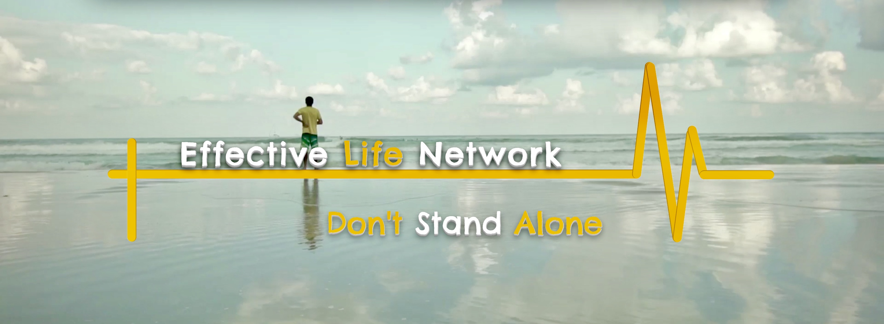

Network Application

| Church or Ministry Name |  |
| --- | --- |
| Ministry Leaders’ Name and Title |  |
| Year of Formation |  |
| Home Address |  |
| Ministry Address if different |  |
| Contact Phone Number |  |
| Email Address |  |
| Website Address |  |

Contact Information: Are you a member of a church or other networks? Please give details:

If so, do you have their support in joining Effective Life Network?

Yes / No

Your Pastor’s name and contact details:

How did you hear about this network?

………………………………………………………………………………

………………………………………………………………………………

Have you read and do you agree with Effective Life Network’s statement of faith?

Yes / No

Have you got a current CRB?

Yes / No

ELN carries no legal responsibility to or for its members

Are you a registered charity/company?

Yes / No

If yes, what is your charity number?

………………………………………………………………………………

Have you read and do you agree with E.L.N. statement of faith?

Yes / No

Personal Details :

| Marital status; please give details of partner |  |
| --- | --- |
| Own children’s information: |  |
| Are you in full time ministry? If not, what other work do you do? |  |
| Date of birth: |  |
| Country of birth: |  |

| When did you receive Christ? |  |
| --- | --- |
| When where you baptised in water and in the Holy Spirit? |  |
| What are your main spiritual gifts? |  |
| What are the areas of support you need? |  |

Personal info:

Please give any other information that may be of importance or of interest as we consider your application. If information is not shared, it could be detrimental to the Gospel or ELN and therefore your membership could be cancelled.

Membership no………………………………………….office use only

Please give a brief overview of your ministry and your vision

Effective Life Network provides

Accountability

The network provides a place of accountability for individual growth and ministries’ decisions. It provides the opportunity for people and ministries to look back and critique themselves constructively regarding their own visions and achievements in ministry and how these ones have been achieved and how effective they have been.

We aim as a network to cover its members in prayer and be a place where members can voluntarily discuss their visions, goals, plans, struggles, difficulties and achievements in order to ensure that God’s will is done and He is glorified in and through all.

[Douay-Rheims Bible](http://biblehub.com/drb/proverbs/11.htm)

“Where there is no governor, the people shall fall: but there is safety where there is much counsel.” Proverbs 11:14

Mentoring

Mentorship is a relationship in which a more experienced or more knowledgeable person helps to guide a less experienced or less knowledgeable person. The mentor may be older or younger than the person being mentored, but he or she must have a certain area of expertise. It is a learning and development partnership between someone with vast experience and someone who wants to learn.Mentorship experience and relationship structure affect the "amount of psychosocial support, career guidance, role modelling, and communication that occurs in the mentoring relationships in which the protégés and mentors engaged.”

Use of Network Logo

The Effective Life Network logo can be used by all who are a part of the network, but it must be shown to the network leaders before it is made public.

Team Training

Team work is the only way we can be truly effective. It is import to grow the people around you. If your team does not grow, you will not grow. For a team to serve and work well together, there must be unity, communication and understanding. We are happy to train your team with you so that the work you have been called to do will be truly effective. Jesus Himself trained His disciples before they were sent out, and also baptised them with the Holy Spirit so that they would be ready to fulfil every good work.

Confidential Support

We go through all sorts of changes and challenges in life; some time we can drop the ball ( SIN ). Effective Life Network is there to help you stand again, to come through whatever you are facing. We are not there to sit in judgment but to help restore people. Sometimes we are just in need to talk to someone outside of our own team. This helps put things in to perspective and order again. Even if we fall, the Bible says that we should confess our sin to one and other, but many leaders do not do this for fear of being rejected. This can make the problem far worse than it was.

Financial Costs

With most networks, there is obviously a charge involved, which can vary quite considerably. We felt at this time we should not put a fixed charge for being a part of the Network. But, in fact, people should give what they feel God has laid in their heart, whether this be a tithe, a monthly gift, or a one-off annual gift. The main priority of the Network is to see leaders, ministries, and churches in a place of health and growth.

Each of you should give what you have decided in your heart to give, not reluctantly or under compulsion, for God loves a cheerful giver.

2 Corinthians 9:7 (NIV)

THE REASON

Effective Life Network was birthed out of a response to various ministries wanting and needing a big brother and fathering hand to support and encourage them. Many ministries and churches have become isolated and their leaders discouraged. They feel too vulnerable to share their real hearts, needs, desires and even crises.

Pastor Matthew himself has felt at many times, isolated and also abandoned when the chips were down instead of being supported in times of crises. Effective Life Network is the result of a time of heartache, when various ministries began to contact him wanting some form of covering and support, but with the freedom to be honest with the challenges faced in ministry and very often, in their personal lives without the fear of being rejected and cut off from the rest of the body of Christ.

We all need to be equipped for what God has called us to. Often we have heard the voice of God correctly, but it is difficult to hear some of the intimate instructions. It's not enough to just fulfil His will; we must also do things His way. This is what Pastor Matthew calls 'The Cup of Tea Theology': anyone can make you a cup of tea - from a stranger to someone you know intimately. But can they make it the way you like it? That comes through intimacy; you must know someone pretty well in order to know how they like things done. You can go into a Cafe and order a cup of tea and the assistant will make you that cup of tea, but will it be how you like it?

Likewise, it's one thing to fulfil God's will, but it's another thing to do it His way. Often the levels of success in ministry are not only due to hearing His will but also His way. This comes down to a close and intimate relationship with The Father. It is not enough to just fulfil His will; things must be done His way as well. Now, that is excellence in the Kingdom.

We can burn ourselves out trying to offer God what we think He would like; we must know what He likes and wants instead. Now, that was the difference between Cain and Abel. Abel brought an intimate offering, while Cain brought one out of duty. Effective Life Network looks to equip ministries so that they can truly minister unto the Lord exactly what He is looking for; His good, perfect and pleasing will.

**DON'T TELL ME HOW TO BUILD A BRIDGE**

**SHOW ME THE ONES YOU'VE BUILT**

Our heart at **Effective Life Network** is to see people's callings fulfilled no matter what that calling is. Whatever you have been called to do, we want to help you maximise it.  So many ministries and projects do not achieve what they could and should for many different reasons, i.e. lack of knowledge, lack of funds and lack of vision. We are called to help each other, serve each other, equip each other and love each other. It's not just a matter of helping only struggling projects but to help good projects become greater and to see ideas become a reality as well. We also have a desire to bridge the gap between different ethnic, social and cultural backgrounds. As Scripture says, "We are to contend as one man." In doing this, we see the very heart of God manifest within the body of Christ in such a way that the world will truly know Him through our love for one another.

Pastor Matthew has been so blessed to see the progress of some of the projects he has been involved with in different countries and cultures over the years, from Nigeria to The Philippines, Ghana, Macedonia, Brazil, South Africa and India as well as making an impact in the UK.

Our local communities are just as important: the people in our neighbourhoods, our work colleagues, our families, those we may not know, that old man and that homeless woman. Also the business men and women, those who serve in government and those from all walks of life.  Effective Life Network has a desire to build-up without burnout. Through first hand experience, Pastor Matthew knows the pressures of leadership, having previously served as a senior pastor for over 15 years and currently serving as the pastor of Effective Life Church ([www.effectivelifechurch.org](https://www.effectivelifechurch.org/)) as well as having pioneered a number of projects and having served God for over 25years in many different capacities, including the joy of meeting Prime Ministers, MPs, Local Counsellors and of being used to change secular mind-sets.

So why do we have this passion? Because leadership is a heavy burden with massive expectations and we do not want people in these roles to give up out of discouragement what God has called them into. We also have a great desire to equip ministers to maximise their ministries to make a tangible difference in the kingdom of God.

**Effective Life Network** is an informal partnership of churches, leaders, groups and ministries with a vision to see a spread of radical Christianity throughout the world. It is open to churches and ministries of all sizes and styles.

All Network partners remain autonomous and are free to make their own decisions and develop their vision. Support is available (if desired). As a Network partner, you will benefit from our range of experience and wisdom, which has been gained over many years of ministry and training opportunities in leadership, evangelism and discipleship, and you will also have access to Pastor Matthew on a one to one level.

Most importantly, through this Network  you will be able to build relationships with other church leaders and ministries. We nurture relationships between partners that are of love, openness and honesty. Network partners have the opportunity to form mutually strengthening relationships with each other. It is a relational network with an evangelical and charismatic focus.

Across the nations, the Holy Spirit is causing Christians to reach out to one another with the hand of friendship. Older churches are being revived and new churches and house groups are springing up. More and more churches worldwide are looking for the reality of friendship relationships. They look for mature wisdom and direction while remaining autonomous and free to make their own decisions as they work out the vision God has given them.

The Network has a vision to take the gospel to the poor, the marginalised and the unchurched. We pursue social justice and responsibility with a strong vision for practical equality. We are a mixture of different cultures and races, all one family together in Christ. It is extremely important that we stand as one body and with the kingdom culture that comes first. Pastor Matthew has a passion to see the people of God working effectively where God has called them.

Effective Life Network does NOT provide financial support.

A vision without a plan could end up just a daydream

**Statement Of Faith**

1. There is one God in three persons: the Father, the Son and the Holy Spirit.

2. God is sovereign in creation, revelation, redemption and final judgement.

3. The Bible, as originally given, is the inspired and infallible Word of God. It is the supreme authority in all matters of belief and behaviour.

4. Since the fall, the whole of humankind is sinful and guilty, has been cut off from God spiritually and is subject to physical death and is under God's wrath and condemnation.

5. The Lord Jesus Christ, God's incarnate Son, is fully God; He was born of a virgin; His humanity is real and sinless; He died on the cross, was raised bodily from death and is now reigning over heaven and earth.

6. Sinful human beings are redeemed from the guilt, penalty and power of sin only through the sacrificial death once and for all time of their representative and substitute, Jesus Christ, the only mediator between them and God.

7. Those who repent and believe in Christ are pardoned all their sins and accepted in God's sight only because of the righteousness of Christ credited to them; this justification is God's act of undeserved mercy, received solely by trust in Him and not by their own efforts.

8. The Holy Spirit alone makes the work of Christ effective to individual sinners, enabling them to turn to God from their sin and to trust in Jesus Christ.

9. The Holy Spirit lives in all those He has regenerated. He makes them increasingly Christlike in character and behaviour and gives them power for their witness in the world.

10. The one holy universal church is the Body of Christ, to which all true believers belong.

11. The Lord Jesus Christ will return in person, to judge everyone, to execute God's just condemnation on those who have not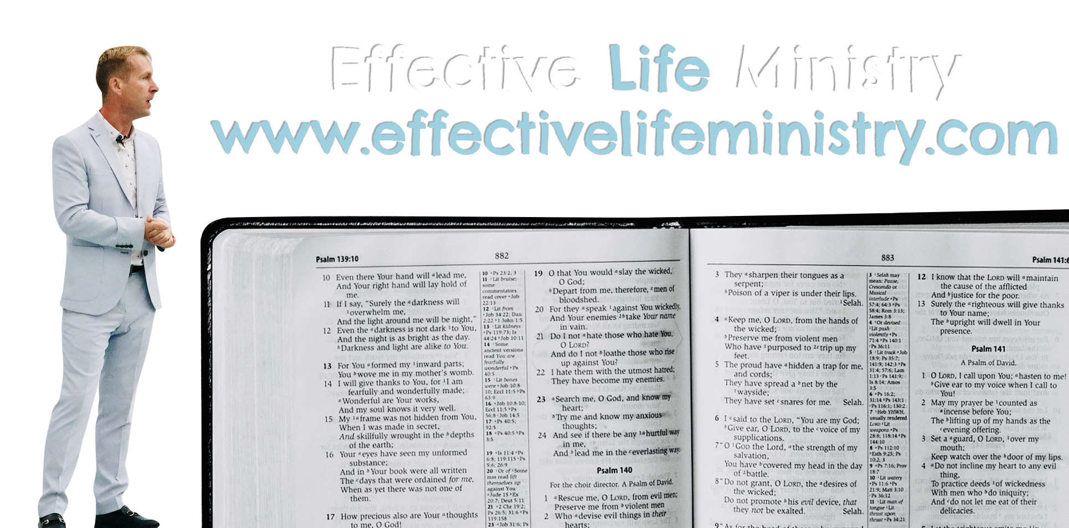 repented and to receive the redeemed to eternal glory.